**Importing and creating environments in Anaconda (Windows 10)**

The Tensorflow and Keras libraries have highly active development communities, so the codebase for both can change in a short space of time. In cases like this, it is worth creating another virtual environment for deep learning projects so you can easily try out new versions without breaking an environment that has previously worked.

The deep_learning.yaml file that can be used by Anaconda to import a Windows 10-compatible environment that should be good to use for the Module 10 labs. I recommend using Anaconda Prompt to import the file, since you will need to use a terminal console for the final step regardless of how you import the environment, but I’ve added the steps for Anaconda Navigator below.

**OPTION 1: Importing an environment in the terminal**

1. Save the deep_learning.yaml file in your Documents folder
2. Open Anaconda Prompt. Make sure it is not the Powershell version (see screenshot below)

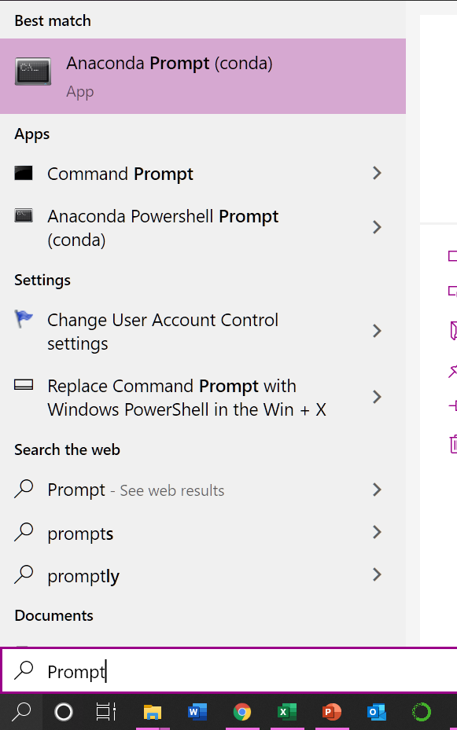

1. The first line in the terminal console should be something like

(base) C:\Users\<YOUR_USERNAME>

Enter the following:

cd Documents

The next line should now read:

(base) C:\Users\<YOUR_USERNAME>\Documents

1. On the command line, enter the following:

conda env create -f deep_learning.yml

You may be asked if you wish to proceed with the installation: type y and enter.

1. When package installation is complete, enter the following:

conda activate deep_learning

Your next line should now read something like:

(deep_learning) C:\Users\<YOUR_USERNAME>\Documents

1. Enter the following:

ipython kernel install --user

1. Enter the following:

conda activate base

1. Open Jupyter notebook. When you create a new notebook, you should see the following:

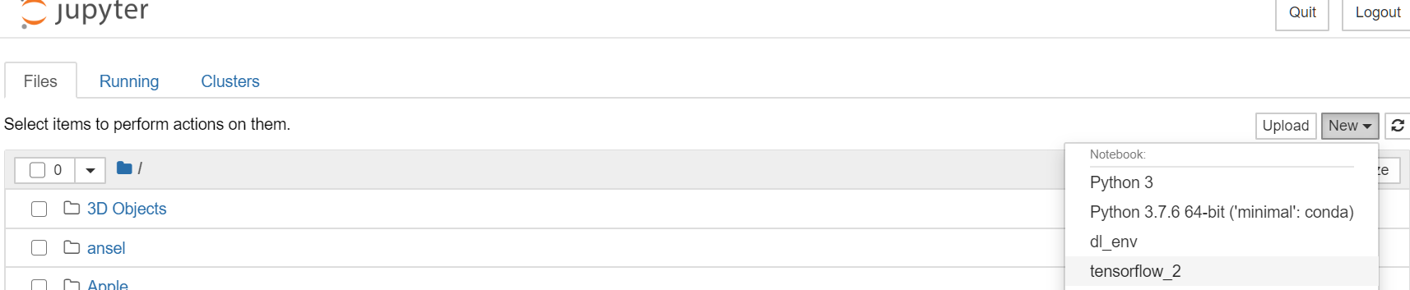

You can now switch to the deep_learning kernel in Jupyter Notebook. If you wish to use the kernel in existing notebooks, go to Kernels > Change kernel when the existing notebook is open.

**OPTION 2: Importing an environment in Anaconda Navigator**

1. Open Anaconda Navigator and go to the “Environments” tab. Click on the Import button near the bottom of the screen.

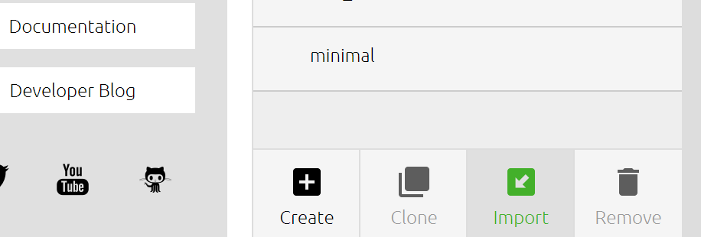

1. Fill in “deep_learning” for the environment Name, and browse for and select the deep_learning.yaml file to fill in the Specification File. You should be able to click on the Import button now.
2. When import is complete, open Anaconda Prompt (look at the screenshot for Option 1 step 2 for the correct app)
3. In the console, type and enter the following:

conda activate deep_learning

You should now have something like this in the next line:

(deep_learning) C:\Users\<YOUR_USERNAME>

1. Go to Option 1 Step 6 and complete steps 6 to 8.